BILKENT UNIVERSITY

SCHOOL OF ENGLISH LANGUAGE

PREPARATORY PROGRAM

2022 - 2023 ACADEMIC YEAR

INTERMEDIATE LEVEL WORDLIST

UNLOCK 3

 | R&W | L&S | EXTRA WORDS
UNIT 1 | 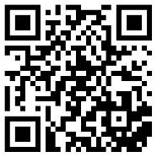 | 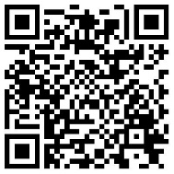 | 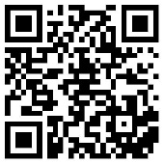
UNIT 2 | 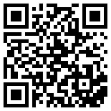 | 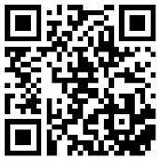 | 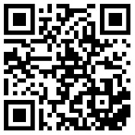
UNIT 3 | 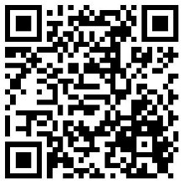
UNIT 4 | 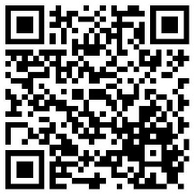
UNIT 5 | 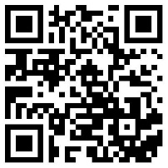
UNIT 6 | 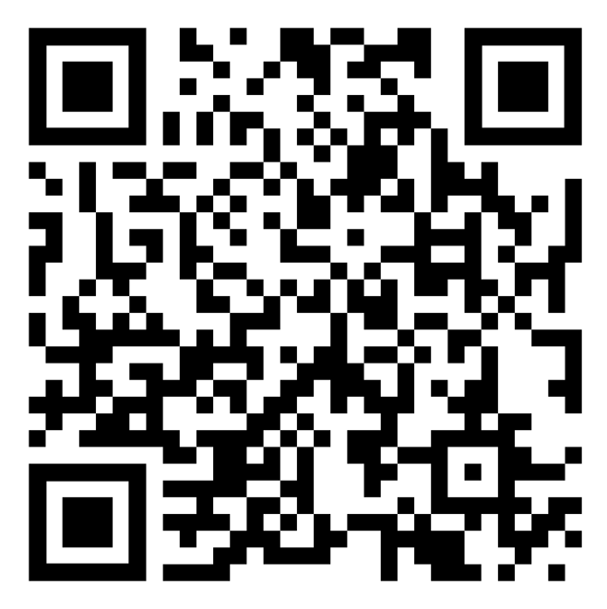
UNIT 7 | 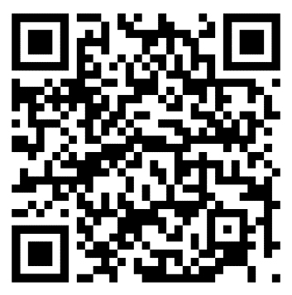
UNIT 8 | 